- SPDM_CMD
The SPDM_CMD command (user-defined function code 65h) is used to attestation and device authentication via Security Protocol and Data Model (SPDM) over MODBus..

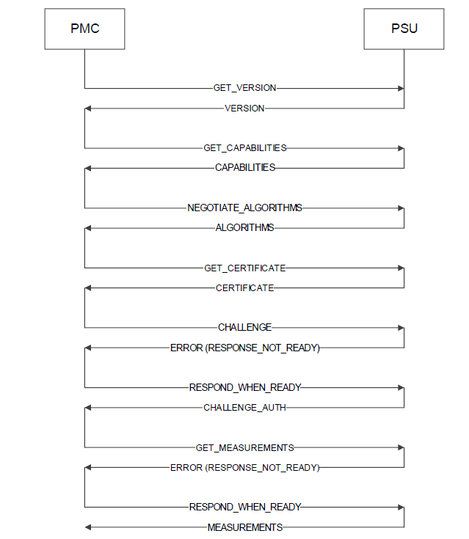

General SPDM Request/Response Flow

Response ( PSU ) | Code
VERSION | 0x04
CAPABILITIES | 0x61
ALGORITHMS | 0x63
CERTIFICATE | 0x02
ERROR (RESPONSE_NOT_READY) | 0x7F
CHALLENGE_AUTH | 0x03
MEASUREMENTS | 0x60
CHUNK_SEND_ACK | 0x05

Supporting Response command ( PSU )

Requestor ( PMC ) | Code
GET_VERSION | 0x84
GET_CAPABILITIES | 0xE1
NEGOTIATE_ALGORITHMS | 0xE3
GET_CERTIFICATE | 0x82
CHALLENGE | 0x83
RESPOND_WHEN_READY | 0xFF
GET_MEASUREMENTS | 0xE0
CHUNK_SEND | 0x85
CHUNK_GET | 0x86

Supporting Requestor command ( PMC )

- Selected SPDM Messages

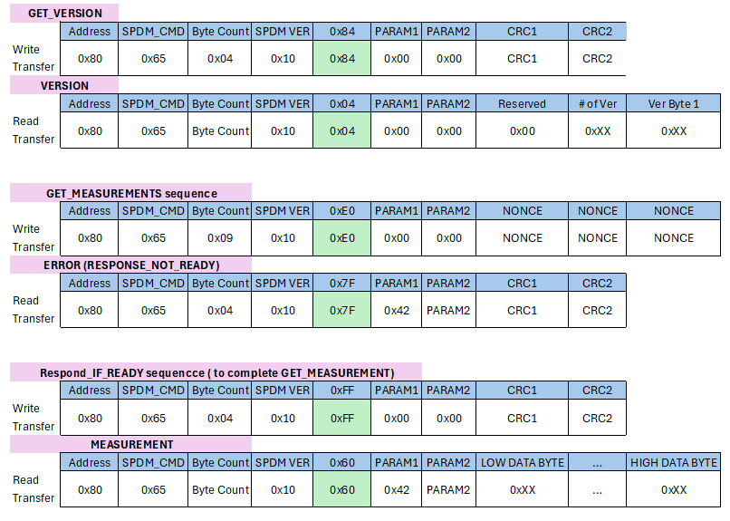

- Measurements & Firmware Attestation
All measurements within the PSU shall be made using a secure, cryptographic hashing algorithm that meets the requirements of the Algorithm Support section of this document. The following areas of memory shall be individually measured at boot time with an immutable boot ROM:

Memory Area | SPDM Measurement Block ID
Main Application (Secondary side Microcontroller) | 01h
Main Application (Primary side Microcontroller) | 02h
Third Microcontroller | 03h
Fourth Microcontroller | 04h
Reserved | 05h-FFh

The PSU shall respond to a GET_MEASUREMENTS request with signed measurements for each area requested. Section 10.11 of [1] describes the protocol for this Request/Response pair. PSU do not require support for recomputing all measurements without requiring a Reset

- References
[1] Security Protocol and Data Model (SPDM) Specification, Version 1.2.0, 2021-12-14, IETF, Document Identifier: DSP0274, https://www.dmtf.org/content/dmtf-releases-security-specification-12

